MY ABF FOR PLAYERS

What does My ABF do?
It gives you a personal ABF account you can login to. Over time this will grow to be your main online interaction for all your bridge activities. You will be able to:
- Manage your personal details
- View your masterpoints
- View, enter, and pay for bridge events
- See announcements from the ABF, your State and your Club.
- Participate in bridge discussion forums
- Run a “Bridge Credits” account with the ABF which you can put money into to pay for your bridge entries
- View your results

Why should I sign up today?
To maintain an account with your own details. This will make entering a lot of bridge events much easier than it is today.
To run a “Bridge Credits” account with the ABF which you can use to pay for your bridge.
To see announcements from the ABF.
To participate in Australian bridge discussion forums.
To be an early adopter of a new system for all Australian bridge players.

How do I sign up?
On the main ABF website click the “My ABF” link on the right hand side: 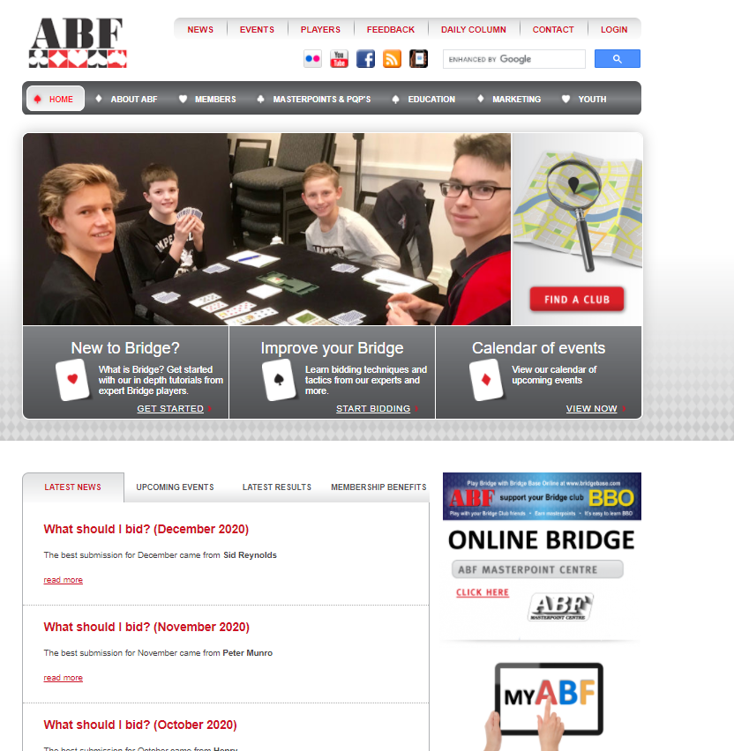
This will take you to a new page. Select “Sign up” at the top right to register for the system
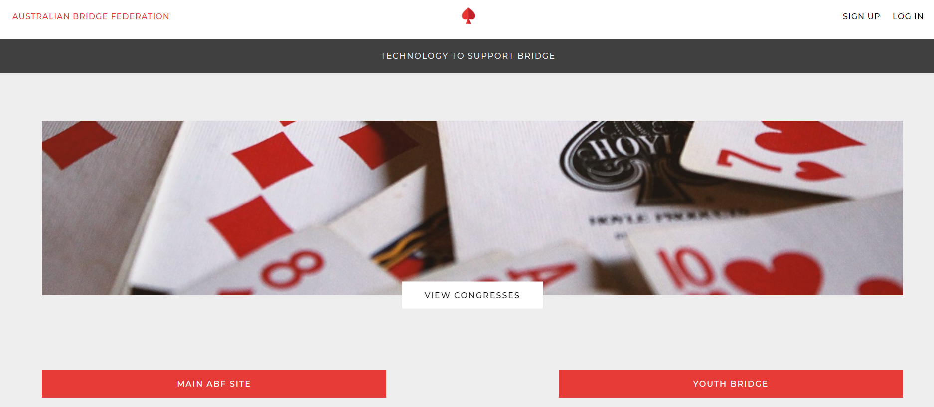

After you have registered you will be able to use the “Log In” link at the top right to access the system.

Once logged in, you will first be taken to your profile page to complete basic details. Then you will be taken to your Dashboard which is effectively your “home page”:
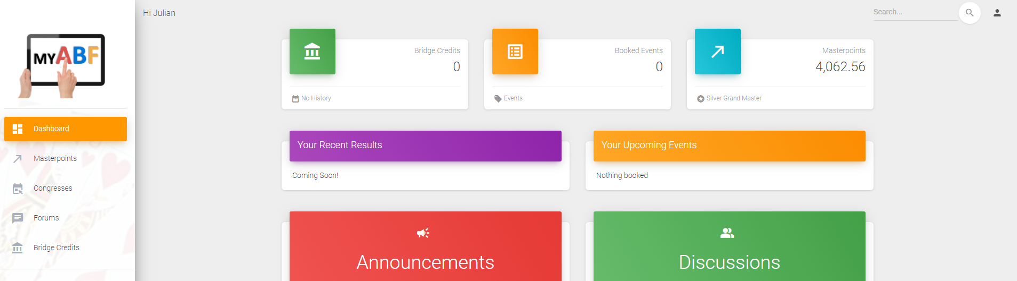

More information?
There are assorted videos on this YouTube channel:
https://www.youtube.com/channel/UCZPuvivkdbzl4kg-cwxQuNQ

