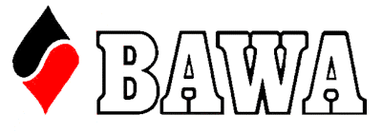
Prize
1st $700
2nd $500
3rd $300

14th and 15th May 2022 10.00am start

Gold Point Event

For ABF Seniors’ events, a player must be born before 1 January 1961.

Melville Bridge Club
431 Canning HWY, Melville WA 6156

Western Senior Pairs
Entry Fee: $200 per pair
Early Bird: Pay online before 7th May: $170 per pair (payment types include credit card (via MyABF credits), and direct deposit).

Entries: https://www.myabf.com.au/events/
Director: Jonathan Free
Tournament Organizer: Jane Reynolds
0402074070, janereynoldsbridge@gmail.com

Cocktail Party** and Presentations
Sunday at approximately 4.30pm

Please Note: There will be no lunch available for purchase at the venue, however there are lunch options 5 min walk away.
We are using the new MyABF system for entries and payments. If you have any problems, or are uncomfortable using this system, please contact the Organiser directly.
Please Note: Due to WA Government Regulation you must be double vaccinated (or possess a medical exemption) to play in this event.
**Covid compliant



