ABF CLUB KNOCK-OUT COMPETITION ENTRANT GUIDE
Event structure & pricing
There will be an entry fee for each round.
Youth discounts
Entries represent clubs so there are no youth discounts.
Find the event you wish to enter in the Program:
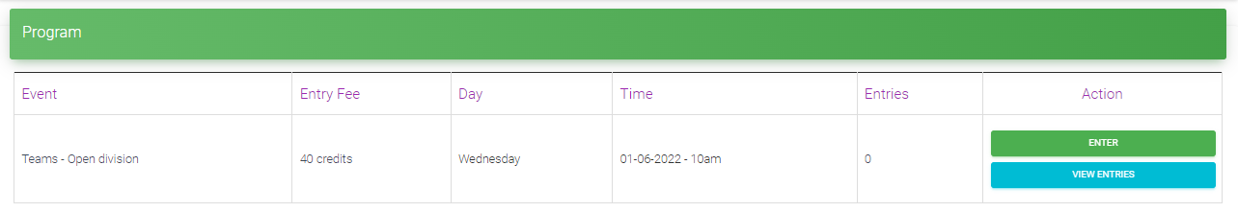
Click on Enter to bring up the entry screen.
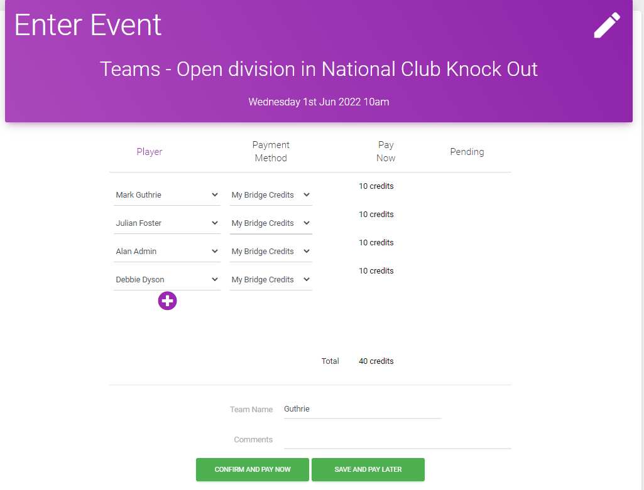
4
1
2
3
1
Player Column
The screen will START with your own name in the first player position. If you are putting in an entry that does not include yourself, you can click on the name and change it.
Add the other players.
2
Payment Method column
Option 1: If YOU are personally paying for the entry (and will be reimbursed by your club)
Make sure the setting says “My Bridge Credits” for ALL of the first 4 players listed. This is the default setting so it is unlikely you will need to change anything (but very occasionally you might find someone saying “Their bridge credits” – in that case click on the selection and change it to “My Bridge Credits”). Make sure the Total at the bottom of the Pay Now column is $40 and there is nothing in the Pending column – as above.
Option 2: If the club is going to pay the ABF by bank transfer
For EACH of the first 4 players in the entry, change the Payment Method column to select “Bank Transfer”. Make sure there is nothing in the Pay Now column and the total at the bottom of the Pending column is $40 – as below.
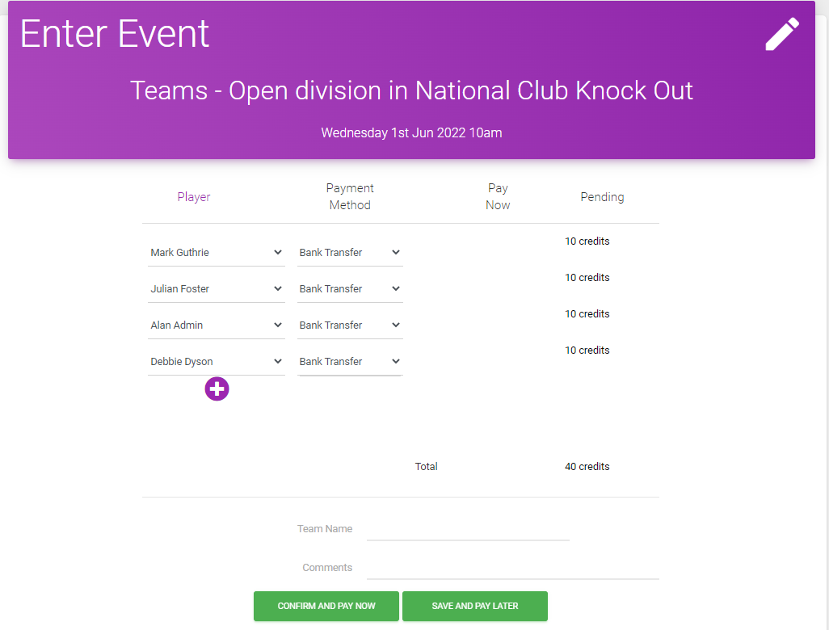
3
Team Name field
The team’s name field will have defaulted to your surname when the entry was started. Edit this field to change it to your club’s name. Remember only one club entry per division.
4
Press Confirm and Pay Now (the left hand of the two green buttons).
This will place the entry.
If you are paying yourself (i.e. you chose option 1) it will take money from your own Bridge Credits account if you have money in it, otherwise it will take you to a card payment screen. Complete payment and seek reimbursement from your club. The entry will be listed as Complete.
If your club is paying (i.e. you chose option 2) then no money will be taken now. The entry will be listed as Pending. The organiser will update that when the ABF has received payment from the club.

