26th Annual
Barrier Reef Congress
Townsville
9 – 13 May 2022
Updated 6 May 2022

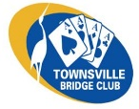
2022 DATES
Monday 9 May – Friday 13 May 2022
ACCOMMODATION
There is a range of accommodation available throughout Townsville. Please see the Townsville Accommodation Map for ideas, or book through Townsville North Queensland | Find Your Shine, Booking.com, Trivago, Expedia. Travel Associates will also help with booking enquiries and accommodation deals. Packages and deals available through Latest Packages & Deals which is updated regularly.

For accommodation enquiries please contact Maria Chippendale 0407 640 949
ALERTS SUMMARY For more detailed information see ABF Alerting Regulations
PRE-ALERTS
List your unusual or complex treatments in the pre-alerts section of the system card. For instance – RCO 2s, Bergen raises, DONT Dbl vs 1NT, unusual carding (leading low from doubletons should be noted in the “leads” section of system card).
ANNOUNCEMENTS
Announce the number of clubs contained in a 1♣ opening and the HCP range of a 1NT opening. Those playing a strong club system just need to announce 1♣ as “Strong 16+”.
ALERTS DURING THE AUCTION
Alert by circling partner’s call and saying “Alert” but don’t offer an explanation unless asked (then aim to be concise, yet complete).
DON’T ALERT
- Any double or redouble
- Any call beyond 3NT, except a conventional opening bid
- A bid of a suit bid or shown by an opponent
- Any 2♣ response to a INT opening bid in an uncontested auction (e.g. Stayman)
- Any Jump Raise in a contested auction
For our New Zealand players, we do NOT use STOP Cards
DO ALERT:
All other conventional calls (such as Transfers, 2♥= hearts and a minor)
‘Unusual’ natural bids. These include: weak jump shift responses, pre-emptive jump raises (but only in uncontested auctions), inverted minors, canapé tendency, negative free bids, transfer accepts that deny four trumps, etc.
At the end of the auction, the declaring side should mark any unusual calls that weren’t alerted at the time. Do this with a plus sign (+).
IF PARTNER STUFFS UP (it won’t be you!)
Declarer/Dummy: If partner fails to alert or provides a wrong or misleading explanation, you should wait until the end of the auction before calling the Director and correcting.
Defenders: wait until the end of the hand before piping up.
BRIDGE MATES
If you are unfamiliar with the Bridgemate Scoring Unit please arrive a few minutes before your first session and ask a Director or other official for a quick tutorial.
BRIDGE MATES II – PLAYER NUMBERS FOR THE PAIRS & TEAMS EVENTS
PAIRS: The player numbers you first enter on the Bridge Mates are your ABF numbers.
TEAMS: NS at the home table should enter the ABF Numbers for the players in your OWN team.
To simplify the process for entering player numbers for these teams, from Round 2 onwards if your team is sitting in the same seats as in Round 1, you may just enter ‘1’ for all four players. The unit will display ‘same as Round 1’ as the player names and the system will correctly record the pairs. If there is a change of player or their position in subsequent rounds, please re-enter the ABF number as applicable.
BUS
A courtesy bus, available for visitors without their own transport, has four pickup stops: Aquarius on the Beach, Grand Chancellor, Palmer Street and Bowen Road (pickup point on Bowen Road will be determined by the accommodation location of the majority of visitors)
The bus will collect and return players on Tuesday, Wednesday, Thursday and Friday. (Please note: no bus service available for the Walk-in Pairs on Monday afternoon)
Seats are limited. To pre-book your seat please contact Rosemary Glastonbury on 0422 222 191. Current Covid-19 restrictions will apply.
CATERING
You are welcome to bring your own lunch as the closest shops are 10 minutes away by car. Michel’s Catering provide pre-ordered sandwiches and salads at the venue. Orders will be taken at 9am on Tuesday, Wednesday and Thursday mornings and delivered prior to sessions end at 1:00pm.
Please advise Di Garside on 0439 598 019 of any special dietary requirements.
Farewell luncheon will be provided at 1:00 pm details to be advised.
Free coffee, tea and light refreshments will be available during short morning & afternoon tea breaks. Water will be provided at stations in the playing area. Please refrain from taking hot or sugary drinks into the main playing area as spilled drinks may damage the surface of the basketball court. A coffee van at lunchtime for the connoisseurs to be advised.
CELEBRITY SPEAKERS
The Speaker Program will commence at 9:30am on Wednesday 11 May. All contributions will be donated to the ABF Youth Bridge. (Please note: we have two courtesy buses on Wednesday. The first will arrive for the Speaker Program and the second will arrive at 1:45pm in time for the first Teams Match).
CLOSING DATE
Entries close on Monday 2 May 2022. Late entries may be accepted at the discretion of the Chief Director.

COMPSCORE TUTORIAL
Peter Busch will conduct a Compscore training at a cost of $5 per person. 11:30am on Wednesday after the Speaker Program
CORRECTION OF SCORES
After each session, a printout of the results for each pair or team will be made available.
If you believe that there is a mistake, you need to follow this procedure:
1. on the board where you believe that there was an error, agree with your opponents that the score was entered incorrectly;
2. make the correction on your printout and have them sign it;
3. the score change request should be referred to the director.
COVID PROCEDURES (Information will be updated from time to time as per current Covid-19 guidelines)
Checking-in at the Townsville Stadium is no longer required, however as per QBA Covid Policy the ABF has confirmed that ALL participants at the Barrier Reef Congress are required to show evidence of double vaccination. This evidence (electronically or in paper form) must be produced to the Tournament Organiser or other nominated person, on arrival. Please ensure your partners and all team members are aware of this requirement.
CONDITIONS OF ENTRY
Regulations: The ABF Tournament Regulations as modified by the ABF Supplementary Regulations will apply.
Each pair is required to have two current ABF approved, systemically identical system cards on the table for the opposing pair before the start of each round. Overseas players will be permitted to use New Zealand and WBF system cards in addition to ABF cards. ABF system cards and guide to completing them are available at this site: http://www.abf.com.au/member-services/system-cards/
Systems: Green and Blue Systems permitted in all events. Red Systems and Brown Sticker Conventions permitted in Open Pairs, Open Teams and Walk-in Pairs.
Yellow Systems Protocol as per ABF Tournament & Supplementary Regulations.
Please see ELIGIBILITY FOR RESTRICTED EVENTS for additional information.
This event will be operating under current Qld Government Covid-19 Guidelines and QBA COVID-19 Policy applies.
No entry will be regarded as complete unless an entry form has been submitted and entry fees paid for each member of the team / pair
The Regulating Authority reserves the right to refuse admission to any entry which includes a player who does not qualify under these conditions of entry or who is not in good standing with any registered bridge club, bridge association or the Regulating Authority.
DIRECTOR
Chief Tournament Director - Dr Laurie Kelso
Senior Director - Peter Busch
DRAW FOR NEXT ROUND
The draw for the next round in the Swiss Pairs and Teams events will be sent to your mobile at the same time it is displayed on the projector screens at the venue. If you wish to receive your results or draw via your mobile, complete the following link www.tinyurl.com/abftext prior to the event. If you have registered at other ABF events you will automatically be on the list.
ELIGIBILITY FOR RESTRICTED EVENTS
Masterpoint requirements as at 31 December 2021
Restricted Pairs: Both players must have fewer than 300mps.
Barrier Reef 300 Teams: The average master points per player must not exceed 300mps, nor may any individual player possess more than 500mps. Additionally, team members who are life masters may not play together in a partnership.
Additional Limitations: A player having won a Restricted event is not eligible to enter that event in subsequent years.
A player may not have previously won two or more ABF events with the same master point restriction or higher as the one entered. Notwithstanding, players who have already entered a restricted category at the time of winning their second such ABF event, will be deemed eligible.
ENTRY FORM
MyABF registration is required to enable submission of an entry to this event. Registration information can be found at MyABF resources and how to sign up.
For MyABF queries Pele 0439 949 060 or Kim 0412 064 903 (manager@qldbridge.com.au)
To lodge an entry for the Barrier Reef Congress, go to My ABF - Congresses and scroll down to May 2022. Click on Barrier Reef Congress and scroll down to Events. Select your event and click on Enter. Your name will be pre-filled and you have the option of including your partner/team. Click Bank Transfer in the Payment Method for each player. When complete, click the Save and Pay Later box.
For payment options see PAYING FOR ENTRIES below
ENTRY FEES
Walk-in Pairs $ 30
Swiss Pairs $160
Teams $580
GOLD POINTS
Gold Points are awarded in all events except Walk-in Pairs when Red Points are awarded.

HOSPITALITY
Welcome drinks and nibbles will be served after the final Pairs Session at approx. 5:30pm on Tuesday.
Farewell luncheon will be provided at 1:00 pm on Friday.
Please advise Di Garside on 0439 598 019 of any special dietary requirements.
MOBILE PHONES
Players are not allowed to use their mobile phones during session times. Please ensure they are either TURNED OFF or on SILENT. Please see Margaret Dousset, Tournament Organiser, to look after your phone if you are expecting an urgent call.
If you wish to receive your results or draw via your mobile, complete the following link www.tinyurl.com/abftext prior to the event. If you have registered at other ABF events you will automatically be on the list.
PARKING
The stadium has free onsite parking for 310 spaces with 6 dedicated handicapped spaces.
PAYING FOR ENTRIES
Direct Deposit: Westpac BSB: 034-212 A/c No: 558992
(Please use your Name & ABF Membership Number as reference on all bank transfers)
Cheque: Payable to: Townsville Bridge Club Inc
Mail to: PO Box 1053, Aitkenvale Q 4814
PENS
Pens will be supplied at the beginning of the event and belong to the players who are responsible for carrying their own pens from table to table.

PROGRAM
Butler Swiss Pairs (Open & Restricted)
Swiss Teams (Open & Restricted)
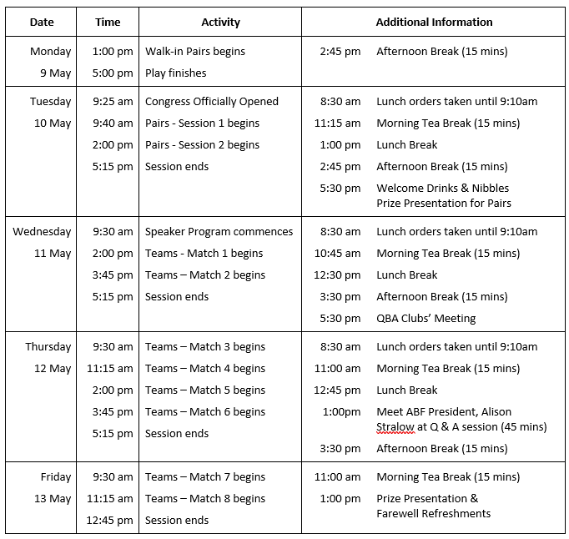
QLD CHECK-IN APP
Checking-in at the Townsville Stadium is no longer required, however as per QBA Covid Policy the ABF has confirmed that ALL participants at the Barrier Reef Congress are required to show proof of double vaccination.
REGULATIONS
The ABF Tournament Regulations as modified by the ABF Supplementary Regulations will apply.

RESULTS & DRAW FOR NEXT ROUND
Mobile Phone: If you wish to receive your results & draw via your mobile, complete the following link www.tinyurl.com/abftext prior to the event. If you have registered at other ABF events will automatically be on the list.
Projectors: Results & next draw will be displayed on the LED screens in the main hall.
Foyer: Results & next draw will be displayed on boards in the foyer.
SCORE BOOKLETS
Score booklets will be provided at the beginning of the event. Caddies will have a limited supply of spare booklets available.
SESSION TIMES – see program for further details
Event | Day | Start | Finish
Walk-in Pairs | Monday | 1:00pm | 5:00pm
Pairs – Session 1 | Tuesday | 9:40am | 1:00pm
Pairs – Session 2 | Tuesday | 2:00pm | 5:15pm
Teams – Session 1 | Wednesday | 2:00pm | 5:15pm
Teams – Session 2 | Thursday | 9:30am | 5:15pm
Teams – Session 3 | Friday | 9:30am | 12:45pm
SPONSORS

STAY & PLAY
Come for the BRIDGE. Stay and play in Townsville. Basking in more than 300 days of sunshine each year, Townsville is an exciting place to visit and stay a while. Come explore tropical islands, wetlands, the Great Barrier Reef, wet tropics rainforests and a glorious beachfront in warm tropical weather. No matter what your holiday style, Townsville offers you a diverse range of historical, military, outback, island, active and tranquil experiences.
Visit Magnetic Island. Sealink NQ is happy to offer a 20% discount on Adult return ferry tickets for our bridge visitors. Please quote the promo code ‘BRIDGE’ when purchasing the tickets at the terminal or online. Sealink NQ also have various packages with ferry, accommodation / car hire.
SYSTEMS AND SYSTEM CARDS
Each pair is required to have two current ABF approved, systemically identical system cards on the table for the opposing pair before the start of each round. Overseas players will be permitted to use New Zealand and WBF system cards in addition to ABF cards. ABF system cards and guide to completing them are available at this site: http://www.abf.com.au/member-services/system-cards/
Systems: Green and Blue Systems permitted in all events. Red Systems and Brown Sticker Conventions permitted in Open Pairs, Open Teams and Walk-in Pairs.
Yellow Systems Protocol as per ABF Tournament & Supplementary Regulations.
TEA & COFFEE
Stations with free coffee & tea will be set up in the foyer outside the playing area and available at any time. Please refrain from taking hot or sugary drinks into the main playing area as spilled drinks may damage the surface of the basketball court. Light refreshments will be served at morning & afternoon tea breaks. A coffee van at lunchtime for the connoisseurs to be advised
TRANSPORT
Courtesy Bus - A courtesy bus, available for visitors without their own transport, has four pickup stops (see BUS heading for more details)
Airport – Hotel Shuttle – Door to door service to inner city motels Airport - Hotel Shuttle
Own Car - The Townsville Stadium has free onsite parking for 310 vehicles with 6 dedicated handicapped spaces.
UNIFORMS
Directors and caddies will be wearing blue tropical shirts
VENUE
Townsville Stadium 40-48 Murray Lyons Cres, Annandale
Take a Virtual Tour Townsville Stadium - Townsville City Council
The design incorporates full disability access throughout the building and has a built-in hearing augmentation system to allow full enjoyment of the audio system.
WEATHER
The average temperature in May in Townsville has a high of 27° and a minimum of 18° with low humidity and little rain. Bring a light jacket for air conditioning. Make sure you bring an umbrella. "A rare May deluge is anticipated for the far North"

ZONE MEETING
Club Representatives Meet & Greet with the ABF President as per program.

