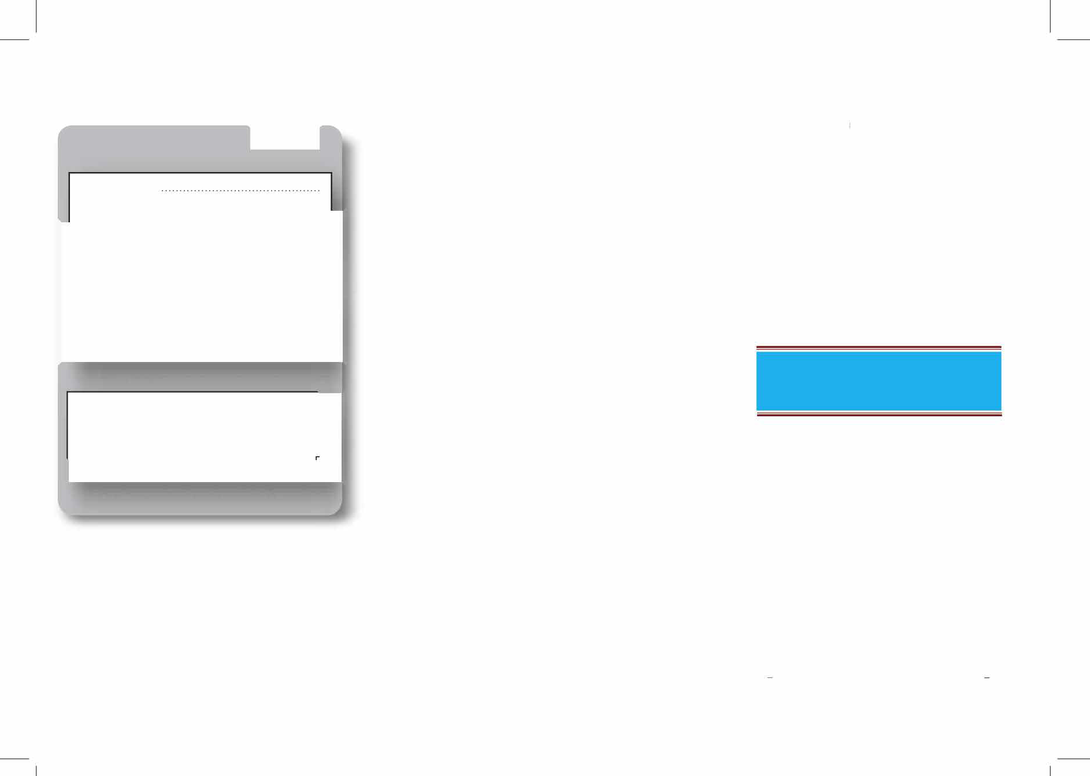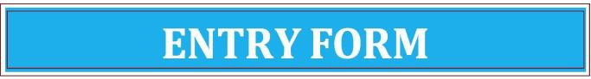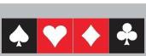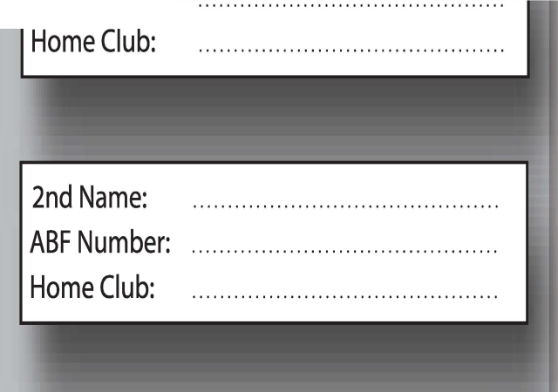

**SWISS PAIRS**

1st Name**:**

ABF Number:

**CONTACT DETAILS**

Name: ..........................................................

Email: .........................................................

Phone: ........................................................

***Entries fees must accompany entry form. Refunds will be given at the discretion of the Committee***

**IMPORTANT NOTE**

All entries will be uploaded to the MyABF website.

Entries received by mail or email will be acknowledged.

Accommodation

The following establishments are located within 500 metres of the congress venue

# * TAMWORTH CENTRAL MOTEL

239 Goonoo Goonoo Rd, Tamworth Phone: (02) 6762 2277

# * ECONO LODGE GATEWAY

236 Goonoo Goonoo Rd, Tamworth Phone: (02) 6765 7022

# * TAMWORTH BUDGET MOTEL

300 Goonoo Goonoo Rd, Tamworth Phone: (02) 67658368

# * COUNTRY CAPITAL MOTEL

193 Goonoo Goonoo Rd, Tamworth Phone: (02) 6765 5966

# * EDWARD PARRY MOTEL

261 Goonoo Goonoo Rd, Tamworth Phone: (02) 6765 9075

# * GOLDEN GRAIN MOTOR INN

228 Goonoo Goonoo Rd, Tamworth Phone: (02) 6765 3599

# * TAMWORTH MOTOR INN

212 Goonoo Goonoo Rd, Tamworth Phone: (02) 6765 4633

# * TOWN & COUNTRY MOTOR INN

217 Goonoo Goonoo Rd, Tamworth Phone: (02) 6765 3244 02

**TAMWORTH BRIDGE CLUB**

invites you to attend its

**2024 50th ANNIVERSARY** **SWISS PAIRS**

**On**

**Saturday, 24th August and Sunday, 25th August**

**S**

**To be held at the Tamworth Bridge Clubhouse**

**7 Hilton Street, Tamworth, 2340**

Tournament Director Ronnie Ng President

Frank Gooley

Conducted under the auspices of Bridge NSW

The ABF has approved the issue of Red Masterpoints at level B4



**E N T R Y F OR M Pleas e d et a c h**

ENTRY FEES

**Swiss Pairs$110 per person**

*Includes lunch & refreshments on both days*

*\*\*Please advise regarding special dietary requirements*

Online Entries: [www.myabf.com.au](http://www.myabf.com.au) or Email: [dtcohen@bigpond.com](mailto:dtcohen@bigpond.com)

Mail Entries: The Convenor

Tamworth Bridge Club

7 Hilton St

Tamworth NSW 2340

Cheques should be made payable

to ‘Tamworth Bridge Club’

Direct Debit Details: BSB: 062 602

Account Number: 2801 0804

\*\**Please quote Surname*

***1st 2nd 3rd***

***RESTRICTED***

***(less than 50 MPs)***

***1st***

***$400***

***$200***

***$100***

***$80***

***(The level of restricted players may be varied depending on entries)***

***BEST LOCAL PAIR (Not winning another prize)***

***1st $60***

**CO N G R E S S PRO GR A M M E**

**Saturday, 24th August SWISS PAIRS**

10.00am Registration

10.15am Opening session of Swiss Pairs

1.15pm Light Lunch

*\*\*Please advise regarding special dietary requirements\*\**

1.45pm Second session of Swiss Pairs

**Sunday, 25th August**

9.00am Third session of Swiss Pairs 12.00pm Lunch

*\*\*Please advise regarding special dietary requirements\*\**

1.00pm Final session of Swiss Pairs  4.00pm Presentation of prizes, light snacks & drinks

ENTRIES CLOSE Tuesday 20th August 2024

Entry fees must accompany the entry form. Refunds will be given at the Committee’s discretion. The Committee reserves the right to alter the programme and prize money if warranted.

**C ON D IT I O N S O F E N T R Y**

1. System cards are MANDATORY. Yellow systems are NOT permitted.



during play.

3. NO smoking or drinking of alcohol is permitted in the clubhouse during play.

4. All players are subject to the NSWBA's Congress Disciplinary Regulations

**E N Q U I R I E S**

Please direct all enquiries to David Cohen (convener) Phone: 0428 664 441

Email: [dtcohen@bigpond.com](mailto:dtcohen@bigpond.com)

**C l u b L ocat i o n**

**Tamworth Bridge Club 7 Hilton Street**

**Tamworth NSW 2340**





        
        
        



