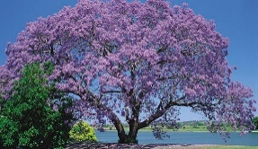

**GRAFTON BRIDGE F2F CONGRESS**

**SWISS BUTLER IMP PAIRS**

**30th & 31st AUGUST 2025**

***Play starts Saturday 10am & Sunday 9.30***

**Cash prizes in masterpoint divisions**

**Conducted under the auspices of BridgeNSW**

**Red Masterpoints at B4 Level**

**Green, Blue & Red Systems and Brown conventions and treatments only**

**Cost $100 per player, $200 per pair**

**PREFER DIRECT DEPOSIT to GREATER BANK**

**BSB: 637 000 A/C NO. 780225017**

**PLEASE INCLUDE * SURNAMES + ABF NO’S WITH DIRECT DEPOSITS**

**\* COMPULSORY FIELD**

**MY BRIDGE CREDITS THROUGH MyAbf**

**All entries via MyABF**

**Entries close 5pm 20th August**

**Tournament Director**

**Mark Miller**

**Event Organiser**

**Denise Llewellyn**

**Tel 0422100601 email** [**neesellewellyn@gmail.com**](mailto:neesellewellyn@gmail.com)

**Held at**

***Grafton District Services Club***

***105-107 Mary Street, Grafton***

***Grafton***

***Tel: 0266403200***

*(No night time play)*