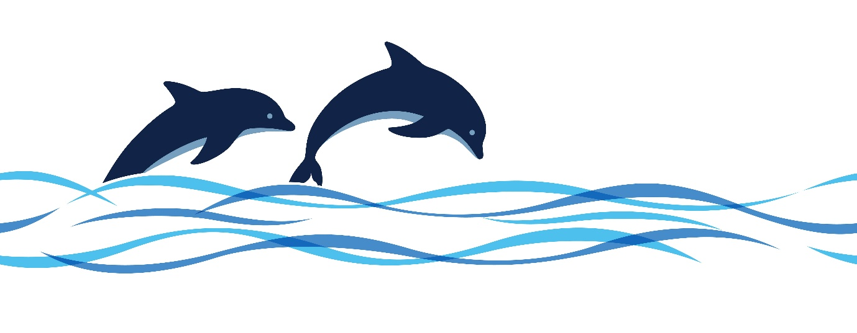

YAMBA BRIDGE CLUB – BRIDGE BY THE SEA
ANNUAL SWISS PAIRS CONGRESS
Will be held at the Yamba Bowling Club, 44 Wooli Street, Yamba
On 23rd & 24th May 2026
Entries close 1st May 2026
Director: Ronnie Ng
We are using MyABF to accept and display entries only.
All payments via Direct Deposit to Yamba Bridge Club
Do NOT pay by Bridge Credits
BSB: 533 000 Bananacoast Community Credit Union
A/C No: 021 329 09 Yamba Bridge Club
Cost: $120 per person (bridge, morning & afternoon tea, lunch both days)
Or $110 per person Early Bird (pay by 1st May 2026)
Early Bird discount only applies for payments made by direct deposit.

Please include Surname and ABF number with direct deposits
Conducted under the auspices of NSWBA
Green & blue Systems only. Systems cards must be available.
The ABF has approved the level of Red Masterpoints at level B4.
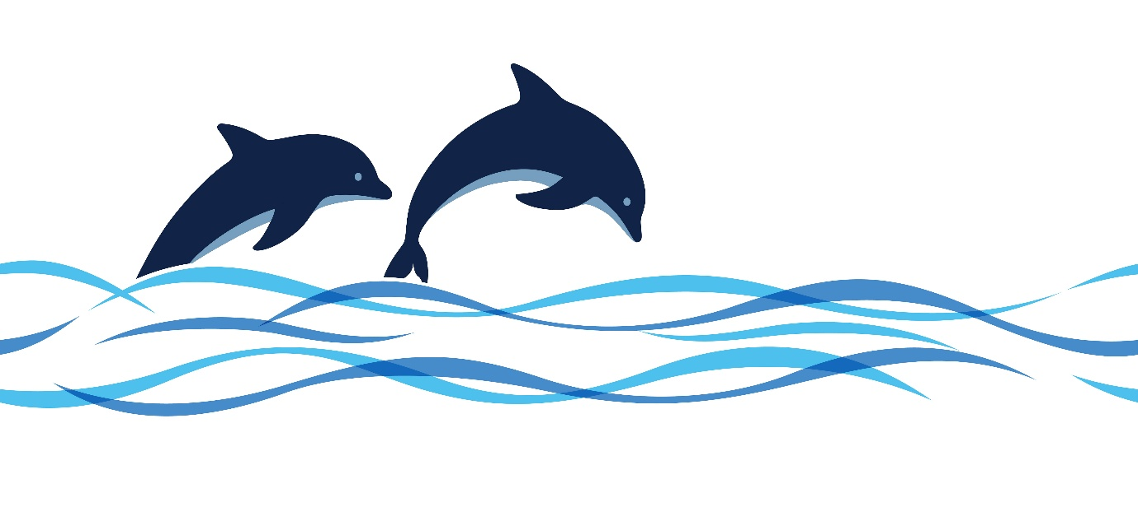
All players are subject to the NSWBA’s Congress Disciplinary Regulations.

