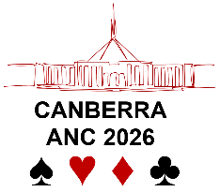
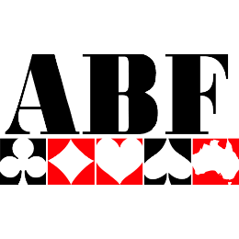
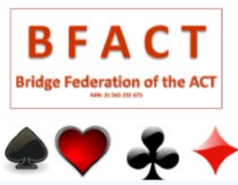

AUSTRALIAN NATIONAL CHAMPIONSHIPS – ELIGIBILITY FOR EVENTS

Interstate Championships (Pairs and Teams)
Entrants to the Interstate Teams event are restricted to one team in each category (Open, Womens, Seniors and Youth) from each state/territory. They must be nominated by their state/territory associations by email to the Tournament Organisers (Lyn Carter or Cathy Nichols) at anc@abf.com.au.
Entries to the Interstate Pairs Championships are open to all, provided that both players are from the same state/territory. Prizes will be awarded in the Open, Womens, Mixed, Seniors and Youth categories. Players may enter directly though the normal MyABF process.
All players in a Seniors team or partnership must have reached the of 65 years (as a minimum) during 2026 (ie, born before 1 January, 1962). All players in a Youth team or partnership must be aged 25 years or under throughout 2026 (ie, born on or after 1 January 2001).

Australian Country Championships (Pairs and Teams)
ANCs are often dominated by players from the capital cities. To make the Canberra ANC a truly national event, we are excited to offer two new red point events exclusively for the members of the smaller or regional bridge clubs.
Eligibility for the Australian Country Club Championships is determined by the size or location of the player’s nominated home club. The club must fit the definition of a ‘country club’ OR a ‘smaller club’:
- A ‘country club’ is one that regularly meets outside the major population centres, that is, outside the greater metropolitan regions of Sydney, Newcastle, Wollongong, Canberra, Melbourne, Geelong, Brisbane, Gold Coast, Sunshine Coast, Adelaide and Perth.
- A ‘smaller club’ is one with less than 150 financial members.
For example, players from the Cairns Bridge Club would be eligible, despite having more than 150 members, because it is located outside a metropolitan area. Similarly, players from the Capital Bridge Club would also be eligible, despite meeting in Canberra, because it has fewer than 150 member.
The Australian Country Club Teams Championships will be held from 6 to 8 July 2026 (alongside the Interstate Teams Championships). Each eligible bridge club may nominate one team of four to six players to complete in the red point event. Teams compete in the name of their club (for example, the ‘Monaro Bridge Club team’). Entries should be submitted by the club officials, by email to the Tournament Organisers (Lyn Carter or Cathy Nichols) at anc@abf.com.au. The entry fee for the three-day event is $960 per team. Clubs are encouraged to financially support their team’s entry, perhaps by raising money in a special event to select their team.
Australian Country Pairs Championship will be held on 9 and 10 July 2026. This event is open to any pair where both players are from a small or regional Club. Pairs do not have to be nominated by a club, nor do they have to be members of the same club. There will be a $30 entry fee rebate for players entering both Australian Country Club Championship events. Eligible players may enter through the normal MyABF process.
We understand that there may be doubts about players’ eligibility, especially in relation to their home clubs. There are good reasons why some players do not play regularly at their nominated home club. Please discuss these cases with Lyn or Cathy.
As entries to ANC events will be limited by the size of the playing rooms, a club wishing to reserve a place for their team can do this by advising Lyn or Cathy at any time.
For those players who do not meet the eligibility requirements for the Australian Country Club Championships and/or are not selected to represent their club, the ANC program includes concurrent three-day teams and two-day pairs events, open to all.

Butler Events (Open and Mixed)
Entries in the various stages of the Open Butler are:
- Stage 1: open to all
- Stage 2: the top 10 placegetters in Stage 1 in each direction (20 pairs in total)
- Stage 3: the top 10 placegetters in Stage 2 (10 pairs in total)
Entries in the various stages of the Mixed Butler are:
- Stage 1: open to all, provided that each partnership consists of one male and one female
- Stage 2: the top five placegetters in Stage 1 in each direction (10 pairs in total)
Entries for the later stages of both events will not open until after the results from the previous stage have been finalised. Entrants to later stages usually have only a few hours to confirm their intention to play in the next stage. Additional entry fees apply to all later stages.
Two Swiss Pairs events run concurrently with Stages 2 and 3 of the Open Butler competition are available for those who do not qualify for the later stages of the Open or Mixed Butler events.

Restricted Congress Events
Some congress events are restricted based on the masterpoint status as at 31 March 2026. These restrictions are:
- Rookies Pairs (4 July) – less than 15 masterpoints
- Novice Pairs (5 July) – less than 100 masterpoints
- Restricted Butler (11 and 12 July) – less than 300 masterpoints
- Graded Pairs (10 July) – the event is open to players at all levels, but prizes are awarded to the highest achieving pairs in each of the open, restricted, rookies and novice categories
- Introduction to IMP scoring (11 July) – less than 50 masterpoints
Additionally, prizes may be awarded in some open events to the best performers in selected restricted masterpoint categories. Decisions on prizes will depend on entries and will be made after 1 June 2026.

Note
The requirements described in this document are intended as a guide to help players decide which ANC events to enter. They are not a substitute for the relevant tournament regulations. The relevant tournament regulations and/or ABF requirements would apply in the event of any inconsistency.

