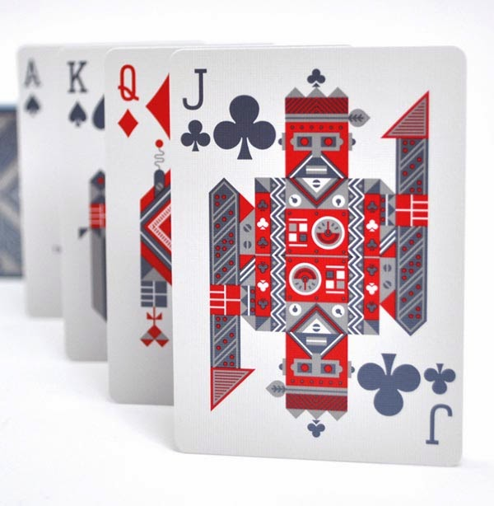
This Photo by Unknown Author is licensed under CC BY-SA-NC

2026 STATE RESTRICTED
CHAMPIONSHIP
RED POINT EVENT
WINNERS WILL RECEIVE $500 EACH TO SUBSIDISE ENTRY TO EVENT OF CHOICE IN THE EASTERN STATES

SUNDAY 12TH APRIL 2026 @ 9.30AM

WEST COAST BRIDGE CLUB
City Beach Civic Centre, 33 Templetonia Crescent, City Beach WA 6015

ENTRY FEE IS $35.00 PER PLAYER
ENTRIES VIA MYABF

Organiser: Robina McConnell execobawa@gmail.com 0400943367
This event is open to all bridge players with <300 masterpoints at the 1st January 2026

