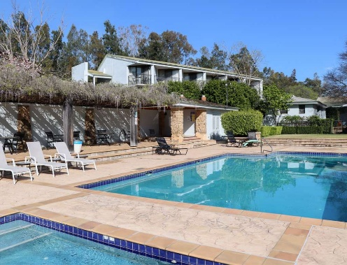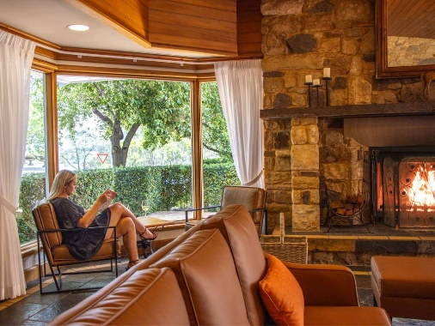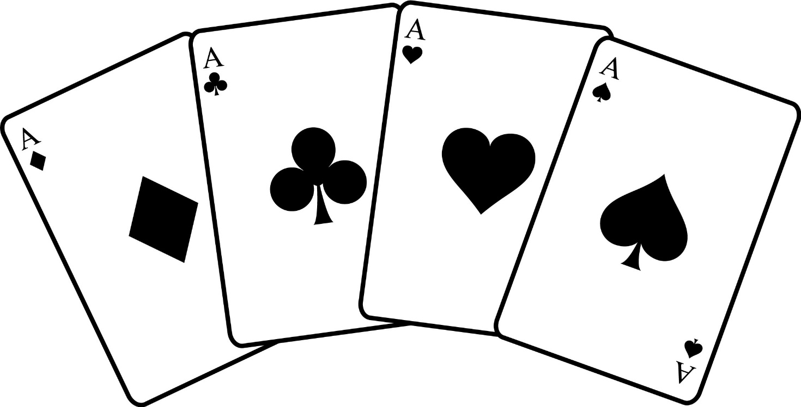
What’s Included
- Breakfast and set dinner every day
- Bridge sessions every morning and evening at 9.30 am and 7.00 pm
- B4 one winner pairs with outright awards for all six sessions
- Prizes for first and second place getters
- Facilities: gym, pool, cafes and NRMA EV charging

Bookings/Contact
Louis Koolen
lkoolen@bigpond.net.au
0419281725
Payment Details: Name: CCLCBC
BSB: 062544 A/c No.: 10280906
Reference: Name and ‘Hunter’
Deposit $100 by end October 2026
2nd to 5th March 2027
Mercure Hotel
Hunter Valley Gardens
Broke Road, Pokolbin
NSW 2320

Hunter Valley Bridge Retreat

Rates
Double/twin pp $645
Single $895
$120 discount for
non-bridge players
Programme
Day 1: 1.00 pm check-in 2.00 pm - 4.30 pm WSP 1 - Opening Leads: Analyse the opposition’s bidding, passive or active lead
5.00 pm dinner 7.00 pm - 10.00 pm bridge
Day 2 9.30 am - 1.00 pm bridge 2.00 pm - 4.30 pm WSP 2 - Thirds Hand Play: Finessing dummy, Rule of 11 and unblocking
5.00 pm dinner 7.00 pm - 10.00 pm bridge
Day 3: 9.30 am - 1.00 pm bridge 2.00 pm - 4.30 pm WSP 3 - Second hand Play: Splitting honours, when to cover an honour
5.00 pm dinner 7.00 pm - 10.00 pm bridge
Day 4: 9.30 am – 1.00 pm bridge followed by prize giving

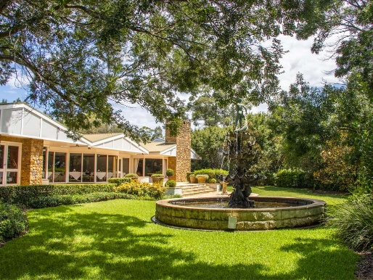

Enjoy four days of bridge, relaxation and great company in the beautiful Hunter Valley!

