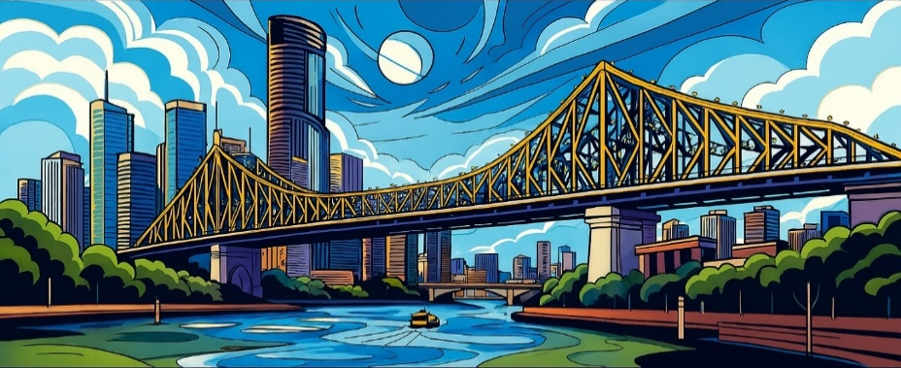

Brisbane Gold Congress 2027
Information
Updated 15/7/2026

Contains Important Information about the Division of the Original U500 Teams into an U500 Teams and an U300 Teams.

Waiting Lists for All Events will Continue.
Moving into an Event will Depend upon Natural Attrition.

Information is being updated as it becomes available.

UPDATE ON CAPACITY AND INTRODUCTION OF AN U300 TEAMS

The option on a small amount of additional space has been exercised and the U500 Teams will be divided to allow a capacity of 60 tables for the U500 Teams and 40 tables for an U300 Teams.

There are no further options on additional space.

This is a complex matter so please be patient.

Australian players must have fewer than 300 masterpoints as at 30th September 2026 to be eligible for the U300 Teams.

New Zealand players must have been less than NZ Provincial Master as at 30th September 2026 to be eligible for the U300 Teams.

Grand Slam players must have had a rating of 56% and under as at 30th September 2026.

The U500 Teams has been closed to allow the division to be done. Fresh waiting lists will start should the new U300 Teams event and/or the original U500 Teams event fill.

WAITING LISTS

Events are closed when they reach nominal capacity and a waiting list is opened. This allows orderly progression into an event as vacancies occur.

The only way onto a waiting list is to email the Brisbane Gold Entries Coordinator, Jacqui Dudurovic, brisbanegoldentries@gmail.com providing the name of the event to be entered and the ABF numbers for the known players. TBAs may be included.

Should a vacancy occur and there are no players on the waiting list, the event will re-open and entries may be made in the normal way.

Please go on to a waiting list if you want to play however, being able to become an actual entry will rely on natural attrition as no blocks of additional space are available.

CAPACITY OF THE VENUE - UPDATED

Space is limited. Initial entry* is capped as follows:
- 100 tables for the Open Matchpoint Pairs, Open Teams and Open Cross-Imp Pairs
- 60 tables for the U500 Teams, U500 Matchpoint Pairs and the U500 Cross-Imp Pairs
- 40 tables for the U300 Teams
* An entry has the correct number of eligible players all of whom have paid the correct entry fee.
Incomplete entries may be made on MYABF if captains have not finalized their pair or team. Incomplete entries are ranked equally with completed entries in determining when initial capacity* is reached and a waiting list is opened.
Captains are requested to replace TBAs with eligible players as soon as possible in consideration of those on waiting lists.

2027 DATES

Saturday 30th January 2027 to Saturday 6th February 2027

No Frills Walk In 5 pm Friday 29th January 2027

ENTRY FORM

There is no entry form.

If for any reason an entry cannot be made via My ABF – Brisbane Gold please email the Brisbane Gold Entries Coordinator, Jacqui Dudurovic, brisbanegoldentries@gmail.com with all relevant information.

ABF NUMBER AND MYABF REGISTRATION

All Australian and international players require an ABF number to play in the Brisbane Gold Congress. If you have an ABF number but don't remember it, you may search for it here - ABF Masterpoint Centre.

New Zealand and other international players requiring an ABF number should email masterpoints@abf.com.au with their First Name, Second Name, DOB, Gender and Country of Origin. Country of Origin determines entry into the NZ Players Club or the Foreign Players Club.

Once you have an ABF number, you need to be registered with My ABF before submitting an entry to any event.

Please use the same given name or nick-name used for your ABF Player Registration.

Once you have done this, you will be sent an email to activate your account. Check spam for the activation email if you don’t receive it.

After you activate your account, you will be taken to a site with your profile. Include your email address, mobile phone number and date of birth.

For information on using MYABF - Australian Bridge Federation » Players

There is no entry form.

Players having difficulty with entering are asked to contact the Brisbane Gold Entries Coordinator, Jacqui Dudurovic, brisbanegoldentries@gmail.com.

ACCOMMODATION

Many chains are represented in the Brisbane CBD and there are too many possibilities to mention. Apart from those in the very centre, there are several that may suit you in Elizabeth and Charlotte Streets and further towards the old botanic gardens.

South Bank is well worth considering. Staying further out and using the cheap public transport network is an option.

This map shows just a few of the closest but is not to be seen as a recommendation. Indigo is connected to Voco Brisbane City Centre by a passageway. The congress staff have been booked into Meriton Suites Herschel Street just a 5-minute walk from the venue.

Please don’t hesitate to contact the Tournament Organisers if you have queries.
15% off Best Flexible Rate Voco Brisbane City Centre
Select your room

FORMAT

Subject to any minor changes in the Brisbane Gold Supplementary Regulations.

Brisbane Gold Open Matchpoint Pairs Championship:

Saturday 30th January: Two 27-board sessions Web Mitchells (same as 2025 Gold Coast Congress).
Sunday 31st January: Semi-final: The top 60% NS and EW after the first day play two 27-board sessions Web Mitchells. No pair should play a pair they met on the first day however that could happen in the interests of having a balanced movement.
Le Réconfortant: The lower 40% play two 27-board sessions Web Mitchells for modest NS and EW prizes.
Monday 1st February: Two sessions. Top 30 pairs NS and EW from the Semi-final play Barometer Finals of 10 tables each: Championship, Plate and Consolation.
The rest of the field, including those who played in Le Réconfortant, play in the Swiss Matchpoint Pairs Consolation.

Brisbane Gold U500 Matchpoint Pairs Championship:

Similar format to the Open except that there will be only two Barometer Finals: Championship and Plate.

Brisbane Gold Open Teams Championship:

Tuesday 2nd Wednesday 3rd Thursday 4th February: Twelve 14-board matches Swiss qualifying. 4 teams move into the Semi-finals starting Friday 5th February. The Final starts late afternoon Friday 5th February and continues Saturday 6th February.

Brisbane Gold U500 Teams Championship:

Same qualifying rounds as the Open Teams but that there will be only two teams playing in the Final on Friday 5th.

Brisbane Gold U300 Teams Championship:

Same qualifying rounds as the Open Teams but that there will be only two teams playing in the Final on Friday 5th.

Brisbane Gold Open and U500 Cross-Imp Swiss Pairs:

Separate Fields. Three sessions. Two on Friday 5th February and one on Saturday 6th February.

CROSS-IMPS - WHAT ARE THEY?

Pairs playing Cross-Imps usually use ‘Team Tactics’ as for a Butler pairs event. While scoring an Average Butler is based around a datum created after removing some number of top and bottom scores, cross-imping uses all scores.

Virtually, every pair from the other field comes back to your table and scores up as though you had played a teams match. The imp results are averaged and converted to Victory Points.

If you would like to read more, here is a link to an article written by Chief Scorer Peter Busch:
https://qldbridge.com.au/wp-content/uploads/2026/05/What-is-cross-imping.pdf

ENTRY FEES*

Open & U500 Matchpoint Pairs Championships $270 per player 6 sessions
Open, U500 and U300 Teams Championships $270 per player 6 sessions
Open & U500 Cross-Imp Swiss Pairs $135 per player 3 sessions
Walk-In Pairs TBA 1 session
*Please see below for Youth discount.

ENTRY FEE – DISCOUNT FOR YOUTH

As per ABF policy, players who have not reached their 25th birthday by 1/1/2027 or who have their 25th birthday during 2027 are eligible for a 50% discount.

An entrant is to provide his or her birth date to receive the discount. Members of the ABF Youth Club have fulfilled this requirement provided that they do not turn 26 during 2027.

ENTERING

An entry is not complete until full payment is made together with having the names of two eligible players for a pairs event or having the names of at least four eligible players for a teams event.

Incomplete entries may be made on MYABF if captains have not finalized their pair or team. The expectation is that a sufficient number of registered players will be provided as soon as possible.

Please enter and pay online from 1st July 2026 at My ABF – Brisbane Gold

Online entries i.e., via MYABF, close 48 hours prior to the published starting time of any event.

Late entries for the Matchpoint Pairs Championships and Teams Championships may be accepted for a further 24 hours at the discretion of the Tournament Organisers. Late entries may only be made by contacting the Brisbane Gold Entries Coordinator, Jacqui Dudurovic, brisbanegoldentries@gmail.com.

Entries will be accepted until 8.00pm on Thursday 4th February for the Cross-Imp Swiss Pairs events which start on Friday 5th February, 2026. Please contact the Brisbane Gold Entries Coordinator, Jacqui Dudurovic, brisbanegoldentries@gmail.com once online MYABF entries have closed.
ELIGIBILITY - U500

All players must have had fewer than 500 masterpoints at 30th September 2026 (as recorded in the October 2026 ABF Masterpoint Centre Update) or meet one of the following requirements:

- New Zealand players must have been less than NZ Master as at 30th September 2026.

- International players from other countries may apply to enter U500 events if they are eligible to play in events with similar criteria within their own NBO. The right to enter an U500 event will only be granted after the applicant’s eligibility has been verified. The Tournament Organisers’ decision in respect to such eligibility is final and not subject to appeal

- Grand Slam players must have had a rating of 57% or below as at 30th September 2026.

Further, a player who has won two or more ABF U500 or higher events is not eligible to enter the U500 events. (Note: Winning a one-day event or winning an event with fewer than 10 tables does not count towards the number of events won.) Notwithstanding, a player, who, at the time of winning their second such event has already entered a Brisbane Gold Congress U500 event with a partner and/or teammates who is/are eligible, will be deemed eligible to compete in the event entered.

ELIGIBILITY - U300 TEAMS

Australian players must have had fewer than 300 masterpoints at 30th September 2026 (as recorded in the October 2026 ABF Masterpoint Centre Update) or meet one of the following requirements:

New Zealand players must have been less than NZ Provincial Master as at 30th September 2026 to be eligible for the U300 Teams.

International players from other countries may apply to enter U300 events if they are eligible to play in events with similar criteria within their own NBO. The right to enter an U300 event will only be granted after the applicant’s eligibility has been verified. The Tournament Organisers’ decision in respect to such eligibility is final and not subject to appeal

Grand Slam players must have had a rating of 56% or below as at 30th September 2026.

Further, a player who has won two or more ABF U300 or higher events is not eligible to enter the U300 events. (Note: Winning a one-day event or winning an event with fewer than 10 tables does not count towards the number of events won.) Notwithstanding, a player, who, at the time of winning their second such event has already entered a Brisbane Gold Congress U300 event with a partner and/or teammates who is/are eligible, will be deemed eligible to compete in the event entered.

ELIGIBILITY - GRAND SLAM PLAYERS FOR U500 EVENTS

Grand Slam players must have a rating of 57% and under as at 30th September 2026.

ELIGIBILITY - GRAND SLAM PLAYERS FOR U300 TEAMS

Grand Slam players must have a rating of 56% and under as at 30th September 2026.

ELIGIBILITY - NEW ZEALAND PLAYERS FOR U500 EVENTS

New Zealand players must have been less than NZ Master as at 30th September 2026 to be eligible for U500 events.

ELIGIBILITY - NEW ZEALAND PLAYERS FOR U300 TEAMS

New Zealand players must have been less than NZ Provincial Master as at 30th September 2026 to be eligible for the U300 Teams.

ELIGIBILITY - INTERNATIONAL PLAYERS FOR U500 AND U300 EVENTS

International players from countries other than New Zealand must play in the Open unless granted eligibility to play in the U500 or U300 events.

They may only apply to enter U500 and U300 events if they are eligible to play in events with similar criteria within their own NBO. The right to enter an U500 or U300 event will only be granted after the applicant’s eligibility has been verified. The Tournament Organisers’ decision in respect to such eligibility is final and not subject to appeal.

SPECIAL CATEGORY PRIZES – PAIRS BAROMETER FINALS*

Pairs receiving a prize for a major placing in a Pairs Barometer Final* are ineligible for a special category prize.

The number of special category prizes will depend upon the number of entries.

Any special category prize not awarded shall lapse.

Special category prizes will be awarded in a pre-determined order by working down through the results of the Championship, Plate and Consolation (as required).

No pair may win more than one special category prize.

Any special category prize not awarded shall lapse.

* ‘Barometer Final(s)’ means the Open Matchpoint Pairs Championship, Plate and Consolation and the U500 Matchpoint Pairs Championship and Plate.

CATEGORY PRIZES – MATCHPOINT PAIRS SWISS CONSOLATIONS

Pairs who have won an overall prize in a Matchpoint Pairs Swiss Consolation are ineligible for a category prize.

Pairs who have won a prize in Le Réconfortant are eligible to win an overall prize in a Matchpoint Pairs Swiss Consolation. They may also win a category prize providing they haven’t won an overall prize.

The number of category prizes will depend upon the number of entries.

Category prizes will be awarded in a pre-determined order.

No pair may win more than one special category prize.

There must be at least 10 pairs within a category for a category prize to be awarded.

Any category prize not awarded shall lapse.

CATEGORY PRIZES – OPEN, U500 AND U300 TEAMS CHAMPIONSHIPS

Teams receiving a prize for an overall placing in the Open Teams, the U500 Teams or the U300 Teams are ineligible for category prizes.

The number of category prizes will depend upon the number of entries.

Category prizes will be awarded in a pre-determined order and no team may win more than one category prize.

There must be at least 6 teams within a category for a prize to be awarded.

Any category prize not awarded shall lapse.
CHANGING EVENTS

Movement between events will not be permitted on the starting day of an event without permission from the Chief Director and the Chief Scorer. The request should be made at the Bridge Administration Office (ground floor).

ENTRIES – MYABF REFUNDS – BEFORE CLOSING TIME FOR ENTRIES

Should you withdraw from an event for which you have paid entry fees prior to the closing time for online entries then those fees will be returned to your MYABF account.

Should you wish to have fees returned to the credit card you used to pay originally then please go to My ABF How to Withdraw an Entry and Request a Refund and follow the instructions.

ENTRIES – CANCELLATION THEREOF

This is done via MYABF until the online closing time for entries. Please look at My ABF How to Withdraw an Entry and Request a Refund for instructions

ENTRIES – CANCELLATION AFTER MYABF ENTRIES HAVE CLOSED

After MYABF online entries have closed, and up to the published starting time of any event, an entry may only be cancelled/changed by contacting the Brisbane Gold Entries Coordinator, Jacqui Dudurovic, brisbanegoldentries@gmail.com

Please note:
- the refund policy for cancellation after the first-round draw has been published Link
- the refund policy for no shows Link
- the limitations on changing events on the day of the events. Link

ENTRIES – CLOSING TIMES

An entry is not complete until full payment is received.

Online entries will close on MYABF 48 hours before an event is scheduled to start or when capacity is reached, whichever is the sooner.

Late entries for the Matchpoint Pairs Championships and the Teams Championships will be at the discretion of the Tournament Organisers and will close 24 hours before an event is scheduled to start or when capacity is reached, whichever is the sooner.

Entries for the Cross-Imp Swiss Pairs will close 8.00 pm Thursday 4th February 2027. Please note that the closing time for entering online via MYABF is 48 hours before the event is scheduled to start as stated above. Please contact the Brisbane Gold Entries Coordinator, Jacqui Dudurovic, brisbanegoldentries@gmail.com once online MYABF entries have closed.

No move from Open to U500 and vice versa will be permitted on the starting day of any event without permission from the Chief Director and the Chief Scorer. The request should be made at the Bridge Administration Office (ground floor).

ENTRY FEE – REFUND POLICIES

Entry fees paid to enter a Cross-Imp Swiss Pairs event will be automatically refunded for players qualifying for the Open Teams Championship Semi-finals and the U500 and U300 Teams Championship Finals.

A refund of entry fees will not be made after a failure to show at the scheduled starting time for an event unless extenuating circumstances such as illness or personal emergency are demonstrated.

A 25% administration fee may be deducted from a refund when a contestant withdraws after the first-round draw for the event has been published.

A decision of the Tournament Organisers not to refund an entry fee or to deduct an administration fee is final.

LUCKY DRAW – MATCHPOINT PAIRS CHAMPIONSHIPS

Enter the Brisbane Gold Open or U500 Matchpoint Pairs before 5 pm AEST 31st October 2026 and go in the draw for a refund of your entry fee. Full payment of your entry fee is not required by this time.

One player's name will be drawn under appropriate supervision on 31st January 2027.

Should that person not be playing in the 2027 Brisbane Gold Congress Open or U500 Matchpoint Pairs then there will be one or more redraws until the name of a player who is playing in one of those events is drawn.

The winner will be advised in person and the winner's name will be published online.
The winner's MYABF account will be credited with 270 MYABF Bridge Credits by 1st February 2027. Should the winner have entered at a concession rate then he or she will also receive 270 MYABF Bridge Credits. An equivalent arrangement may be made for a player from overseas winning the draw.

Conducted by Tournament Organisers Jan Peach and Tony Treloar.

PLAYOFF QUALIFYING POINTS

PQP will be awarded for the Open Teams and Open Matchpoint Pairs. The rate will be published here when available.

PUBLIC TRANSPORT BRISBANE

Brisbane has an excellent public transport system with 50 cent fares as we speak.
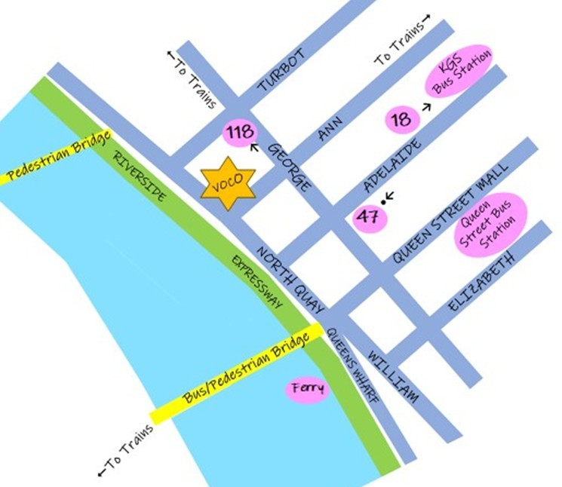

There are two underground bus stations: King George Square and Queen Street. It is a short walk to the venue from either of these. There are buses from further out that pick up in Adelaide Street and either terminate at Adelaide & George (Stop 47); Route 301 | Translink , Route 306 | Translink , Route 309 | Translink , Route 320 | Translink , Route 322 | Translink , or turn right into George and stop at George & Turbot (Stop 118 - same block as venue); Route 375 | Translink , Route 381 | Translink , Route 379 | Translink , Route 380 | Translink if the walk must be shortened.

Roma Street Station is slightly closer to the venue than Central Station and train passengers from the West and South in particular could consider this option.

The Roma Street Busway Station is part of the Roma Street Transport Hub and getting off a bus here rather than travelling through to King George Square or Queen Street could work for you.

From Southbank it is a pleasant 15-minute walk over the Victoria Bridge to the venue. Many buses will take you from the Cultural Centre Bus Station to Stop 18 in Adelaide Street: 107, 116, 192, 197, 210, 212, 214, 215, 220, 230, 235, 300, 305, 555, 875, 882.

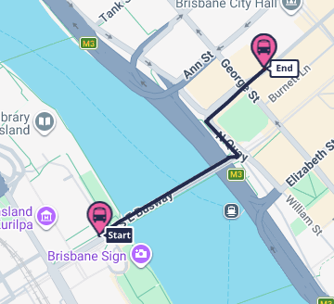
Others will whizz into the Queen Street Bus Station so a little further from the venue.

300, 305, 555 from Stop 46 Adelaide Street will get you back to the Cultural Centre Bus Station.

Arriving by train at Central Station, walk up Ann Street towards the river.

Arriving by train or bus at the Roma Street Transport Hub, walk up Roma then George turning right into Turbot and left into North Quay.

Ferries stop three blocks from the venue.

Plan your trip at Translink

Please note that buses do not pick up in George Street to get back into the middle of the CBD. Various buses travel deeper into the CBD or beyond from Stops 18, 19 and 20 in Adelaide Street.

Outbound buses from Stop 118 near venue will get you closer to Roma Street Transport Hub.

GOLD COAST – GETTING THERE FROM BRISBANE CBD

One hour plus by car depending on the time of travel and your destination – not to mention your speed.

Central Station to the Gold Coast by train takes up to 2 hours depending upon your destination. An adult fare is 50 cents.

PUBLIC TRANSPORT – BRISBANE AIRPORT TO/FROM BRISBANE CBD

Consider Airtrain to/from Central Station. A discount is available for booking online, even on the day of travel. Airtrain.com.au
Please check timetables before purchasing a ticket.

SHUTTLE(S) TO AIRPORT AFTER LAST EVENT SATURDAY 6th FEBRUARY

If there is sufficient interest, one or more shuttles will be coordinated by the congress for flights leaving at a reasonable time after the congress ends.

This service will be provided at cost.

Bookings may be made via MYABF in due course and players are asked to be certain they will use the service before booking.

Coordinating shuttles after the Matchpoint Pairs and Teams has not been discounted but a bit of feedback would be nice before a decision is made.

PUBLIC TRANSPORT – CITYGLIDER BUSES

The Blue CityGlider (Route 60) and the Maroon CityGlider (Route 61) provide high-frequency daily services connecting major attractions, transport hubs and precincts across Brisbane.

PUBLIC TRANSPORT – FREE BUS LOOPS BRISBANE CBD

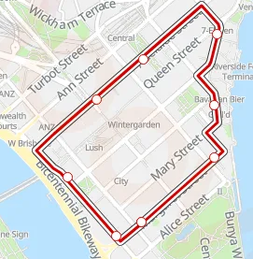
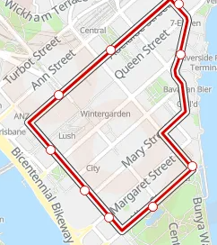
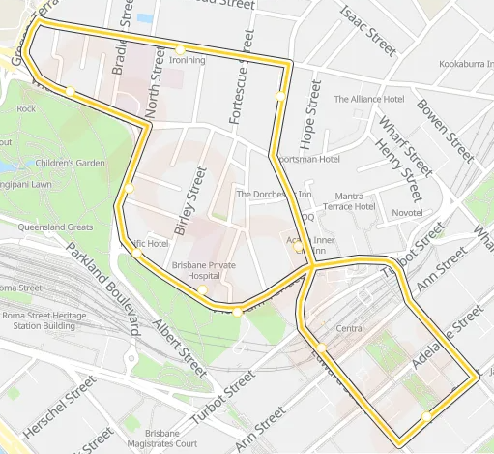
The City Loop buses are purple.

Route 40 (clockwise) and Route 50 (anti-clockwise) may be of interest to players staying towards the old botanic gardens and along the river.

40 and 50 do not run at weekends.

The Spring Hill Loop buses are yellow and run 7 days. The closest stop to the venue for a Route 30 bus is Central Station.

This loop may open up accommodation possibilities in the Spring Hill area.

LUNCHES

Kraft & Co. Bar, located on the ground floor, will offer a range of food and beverage options. Its opening hours are currently 11 am until 4 pm. The menu will be published in due course.

There are numerous places to purchase lunch within a short walk of the venue. Some suggestions will be collated closer to the congress.

Players may bring their own lunch to the venue.

Please do not dispose of food waste in the little rubbish bins at tables. Please consider the cleaning staff when disposing of cups and bottles containing liquid.

NIGHT PLAY

No night play other than the No Frills Walk In Pairs 5.00 pm Friday 29th January 2027.

PARKING

No parking is available at Voco Brisbane City Centre.

Parking in the Brisbane CBD tends towards expensive. There are several parking stations.

Nationwide Parking Station 85 North Quay - Nationwide Parking adjoins the venue.

A Wilson Parking Station is close. Brisbane Quarter

PARTNERSHIP DESK

Players may email Toni Bardon tmbardon@hotmail.com to ask to be matched from others looking for a partner or team mates.

Toni does not go out and find partners and team mates. From those who contact her, Toni will make every effort to match compatible players.

Toni is also happy to help with amalgamating entries containing TBAs.

It is important not to stop searching oneself and, of course, let Toni know if you have been successful.

PAYMENT OF ‘CASH’ PRIZES

All ‘cash’ prizes will be paid in MYABF Bridge Credits unless arrangements are made within 24 hours of the end of the event for an alternative method to be used.

WALK-IN PAIRS – NO FRILLS

5.00 pm Friday 29th January 2027.

AIR CONDITIONING – PLAYER COMFORT

This is a first-time congress at a first-time venue. Nobody knows.

Please dress according to the season and bring a jumper or shawl in case you find yourself in a cold area. Pashminas and wraps will be available. Please ask a caddy if in need and return the item at the end of the session.

If your whole area is too hot/too cold then please ask a caddy to notify the Bridge Administration Office. Directors and Scorers can’t fix it.

WELLNESS GUIDE

Players and officials are asked not to attend any event if they are infectious, or if they are supposed to be isolating or quarantining.

COFFEE, TEA AND WATER

Voco Brisbane City Centre will operate coffee carts offering tea and coffee for $5 in Chelsea Lane (Mezzanine) and on Level 2.

Drinking water will be available in all event spaces.

Kraft & Co. Bar, located on the ground floor, will offer a range of food and beverage options. Its opening hours are currently 11 am until 4 pm.

CONTACTS

Tournament Organisers:

Jan Peach 0487 466 109 janpeach8@bigpond.com
(07) 3352 6929
Tony Treloar 0468 398 843 brisbanegoldto.tony@qldbridge.com.au

Partnership Desk:

Toni Bardon tmbardon@hotmail.com

Entries Coordinator:

Jacqui Dudurovic brisbanegoldentries@gmail.com

