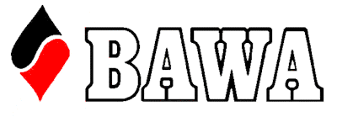

GNOT COUNTRY (2)
2024 FINAL
Melville Bridge Club

GOLD POINT EVENT

Note this is a Pairs Event

Saturday 10th August 1.30 pm start
Sunday 11th August 10.00 am start

There shall be two country events in 2024 eligible Country Players may enter either, but not both. Country (1) will be held at the Albany Bridge Club on the 1st and 2nd June.

Entry is $90.00 per pair. Three pairs from each Final will make up three teams to play in the Online Finals (RealBridge) September 20th – 22nd with eight teams qualifying Australia wide to contest the Final in Sydney 23rd and 24th November.

Regional Organiser is Robina McConnell 0400943367
Tournament Director (Perth) is Neville Walker.
Entry through MyAbf

Eligible Contestants: All members of the following 12 (country) clubs who declare they are permanent residents of the said region are eligible to represent the WA Country region: Albany, Avon Valley, Bridgetown, Bunbury, Busselton, Denmark, Esperance, Geraldton, Kalgoorlie, Kendenup, Kojonup, Mandurah.

